**GEPG SOFTWARE MANUAL**

Step 1 : User have to login through the system using username and password

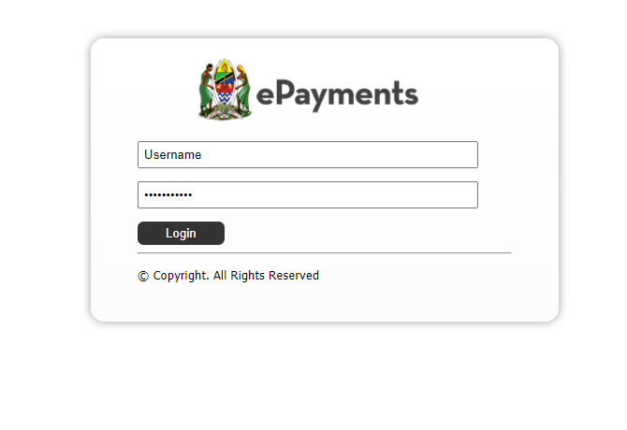

Step 2 : Navigate through Validate Bill Payment in the Transaction menu

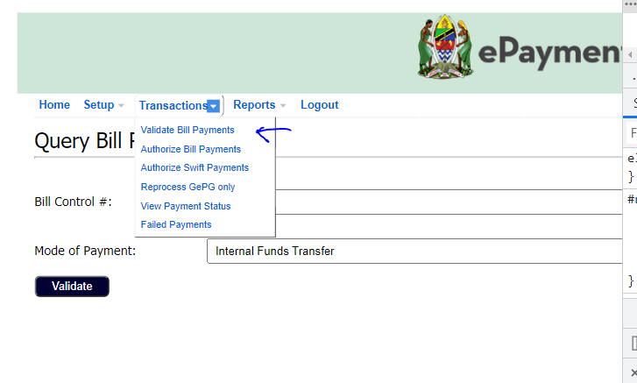

Step 3 : Enter the correct Control No and Select the mode of payment

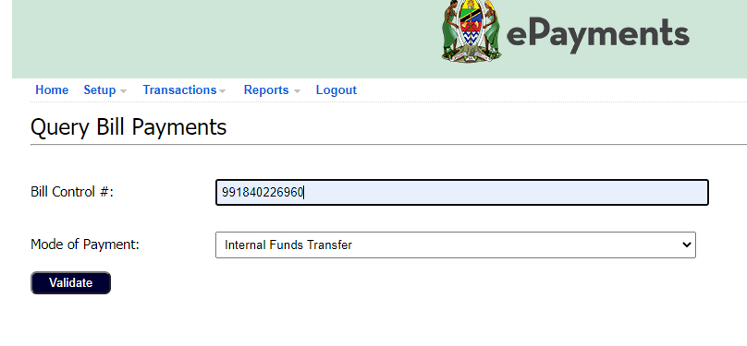

Step 4 : Validate the Control Number Details

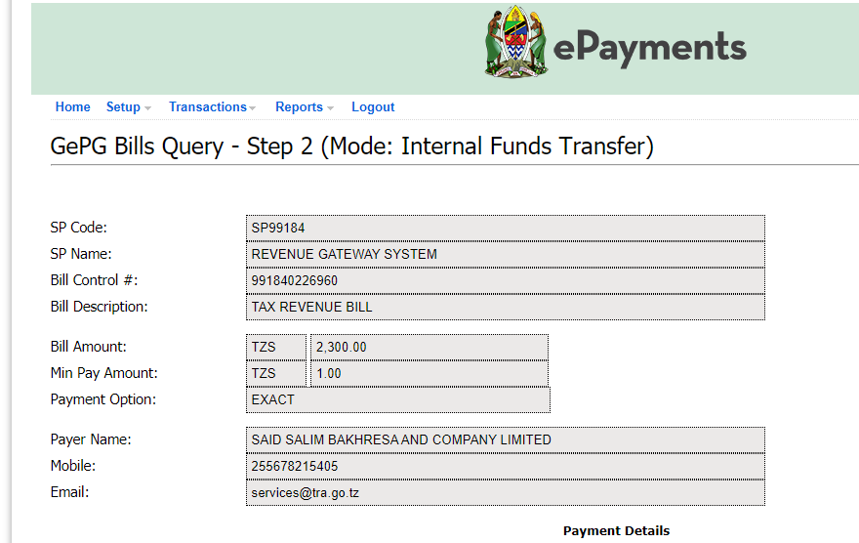

Step 5 : Enter Customer Account and Select Branch

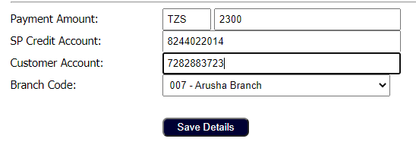

Step 6 : After the payment has been processed, navigate to Authorize Bill Payments menu from transactions menu

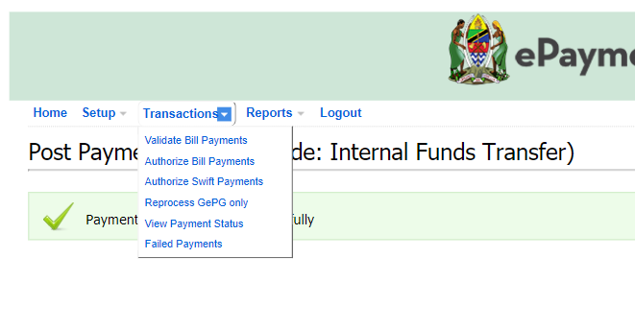

Step 7 : Approve or Reject the Bill Processed with a valid reason

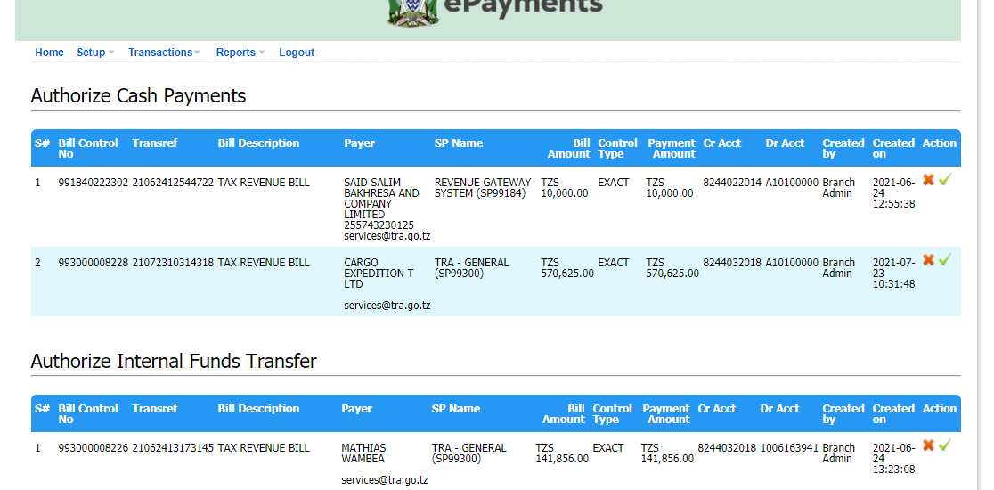

Step 8 : Add a valid reason for rejection

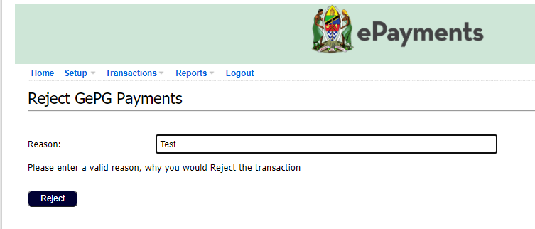

Step 9 : Print Transaction report by navigating into Reports-> Transaction Reports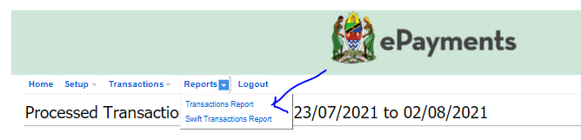

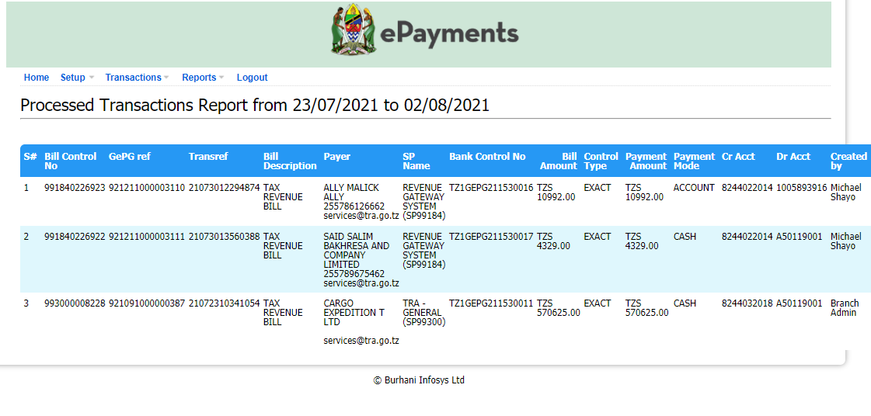

Step 10 : Navigate to View Payment Status and print Receipt

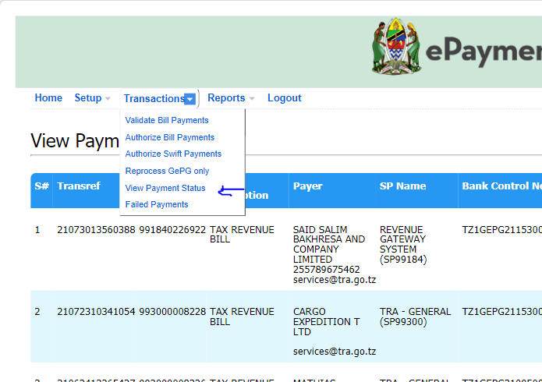

Step 11 : Press the print receipt button

